Flowchart Openai assignment :

**Used Libraries:**

Openai

Logging

Time

Langchain

Streamlit

**We have Importing Required Libraries :** Streamlit, OpenAI, secrets, base64, and components from the langchain library.

OpenAI API Key Configuration: The OpenAI API key is configured using the openai.api_key. The key is fetched from the environment variable OPEN_AI_KEY.

We have further defined LangChainApp Class: The code defines a class called LangChainApp. It contains a method named analyze_text that takes user input and generates Mermaid.js code using GPT-3 through the OpenAI API. The method returns the generated Mermaid.js code.

User Input can be passed to variable : The variable “user_input” contains the input text provided by the user. This text represents the process you want to describe using a flowchart.

Main Function: The main function is defined to create the Streamlit application. It has the following steps:

Streamlit UI elements are created, including a text input and a button.

When the "Analyze" button is clicked, the analyze_text method from the LangChainApp class is called to generate Mermaid.js code based on the user's input.

The generated Mermaid.js code is displayed as text and also converted into a flowchart image using Mermaid.js and Streamlit's st.image function.

Please note that the langchain library is not a standard Python library, and its specific functionalities and usage are not provided in the code snippet you shared. It seems like this library might provide higher-level abstractions or workflows for working with language models, but its details are not visible in the code snippet alone.

Logging library is used to log the input and time taken to generate graph

Git repo:

<https://github.com/kirankkirankumar/Flowchart-openai/blob/main/streamlit.py>

**Input is as below**

**“Describe the process of withdrawing money in ATM if amount is available in account otherwise throw an error”**

Total number of tokens in the given input: 172

Output is as below

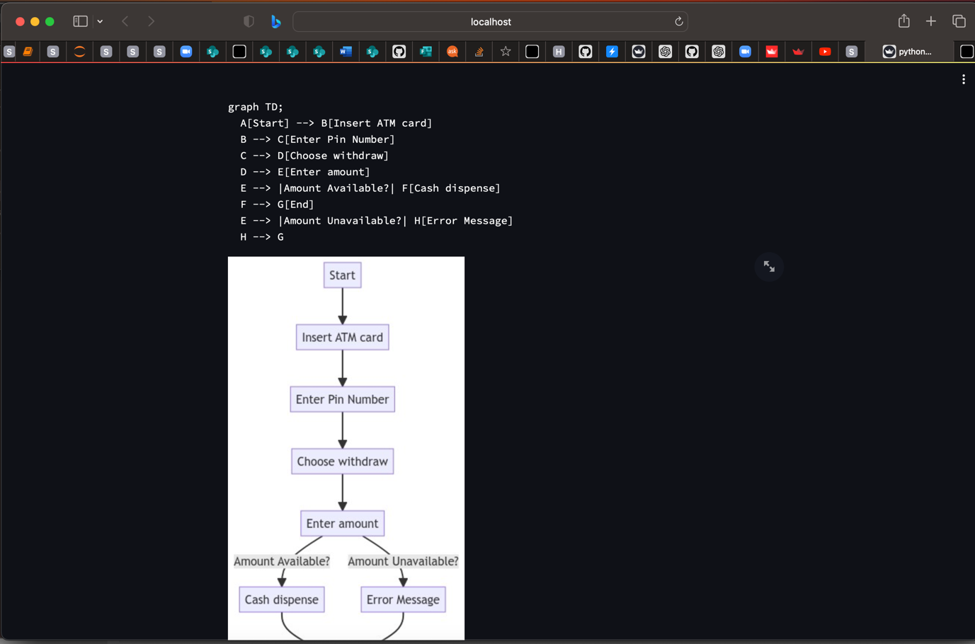

Total time taken for graph to generate is as below :

INFO:root:time taken1.6940100193023682